 | PES University, Bengaluru  (Established under Karnataka Act No. 16 of 2013) | UE20CS904
October 2024 : END SEMESTER ASSESSMENT (ESA)
M TECH DATA SCIENCE AND ARTIFICIAL INTELLIGENCE_ SEMESTER I
UE20CS904 - Mathematical Foundation
Time: 3 Hrs | Answer All Questions | Max Marks: 100
Instructions
- Section A all answers should be handwritten in the answer script.
- Section B and Section C has to be answered in Jupyter notebook (python code)
Section A (20 marks)

1 | a) | Consider the matrix, $A=\left[1 0 -1]; [2 1 0];[ 3 0 5 \right]$. Find $AA^{T},$ Also verify that $AA^{T}$ is symmetric | 4
1 | b) | Define a scalar and a vector. Calculate the angle between two given vectors. The two vectors are, a =4 $\vec{i}$ + 2$\vec{j}$ and b = $\vec{i}$ + 3$\vec{j}$ | 4
1 | c) | What is image convolution ?  Compute the following convolution for the middle pixel with intensity 99. What visual effect will the following convolution have on the image?  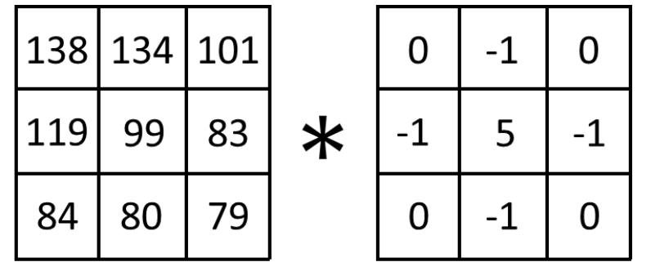 | 4
1 | d) | Explain the concept of affine transformations and describe briefly the matrix representation of translation, rotation, and scaling transformations. | 4
 | e) | What is the effect of learning rate in Gradient descent algorithm? Explain briefly. | 4

Section B (40 marks)
2 | a) | Consider the following matrices:  A = [2 4]; [1 3]  B = [5 6]; [7 8]  - Find the result of the matrix addition ( A + B ).  - Calculate the matrix multiplication ( A ×B ).  - Find the transpose of matrix ( A ).  - Calculate the determinant of matrix ( B ).  - Verify if matrix ( A ) is invertible by calculating its determinant and, if it is invertible, find the inverse of ( A ). | 7
2 | b) | Find EigenValues of and for 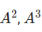,  A=[5 9 1];[6 1 2];[4 1 3] | 7
 | c) | Find the scalar and vector projections of the vector u = 8i + 6j on vector v = i - 7j | 6
 | d) | Find singular value decomposition of matrix A=$\left[11 12 \right];[30 40];\left[15 26 \right]$ | 7
 | e) | Consider the function f(x)=$x^{2}+{4x}^{}+5$  1. Derive the gradient (first derivative) of f(x).  2. Suppose the current point is x = 2. Calculate the gradient at this point.  3. If we apply one step of gradient descent from x = 2 with a learning rate α = 0.1, calculate the updated value of x.  4. Explain why gradient descent moves towards a minimum in this function. | 7
 | f) | Find the critical points of the function f(x)=${ x}^{3}+{5x}^{2}+{8x}^{}-2$ | 6

 | SECTION C – (40 MARKS)
a) | Consider the image “cheeta.jpg” and follow the below mentioned operations.  - Apply grayscale transformation  - Apply Median blur filter  - Apply edge detection (canny filter)  - Rotate the image by 90 degrees  - Scale the image by a factor of 1.5  - Translate the image with the factors(0.2 in the x-direction, 0.1 in the y-direction). | 10
b) | Apply PCA step by step on cancer dataset and find out the principal components that capture 95% variances. (follow the steps given in the notebook) | 15
c) | A particle travels along the path given by the function f(x) = 2sin(x) + 3cos(x), where x represents time in seconds.  1. Plot the path function of the particle.  2. Find the rate of change of the path of the particle:  3. Plot the rate of change of the path of the particle.  4. Find the rate of change of path of the particle at x = 60° (or π/3 radians):  5. Plot the rate of change of the path of the particle at x = 60°. | 15

